**PROJECT REPORT TEMPLATE**

**1.INTRODUCTION**

**1.1 OVERVIEW:**

The project describes well about electricity consumption in India in 2019 and 2020 .

**1.2 PURPOSE:**

The project helps to know well about electricity consumption in India in 2019 and 2020 ie) before and after covid – 19 and to analyse it for different states in India .

**2. Problem Definition & Design Thinking**

**2.1 Empathy Map:**

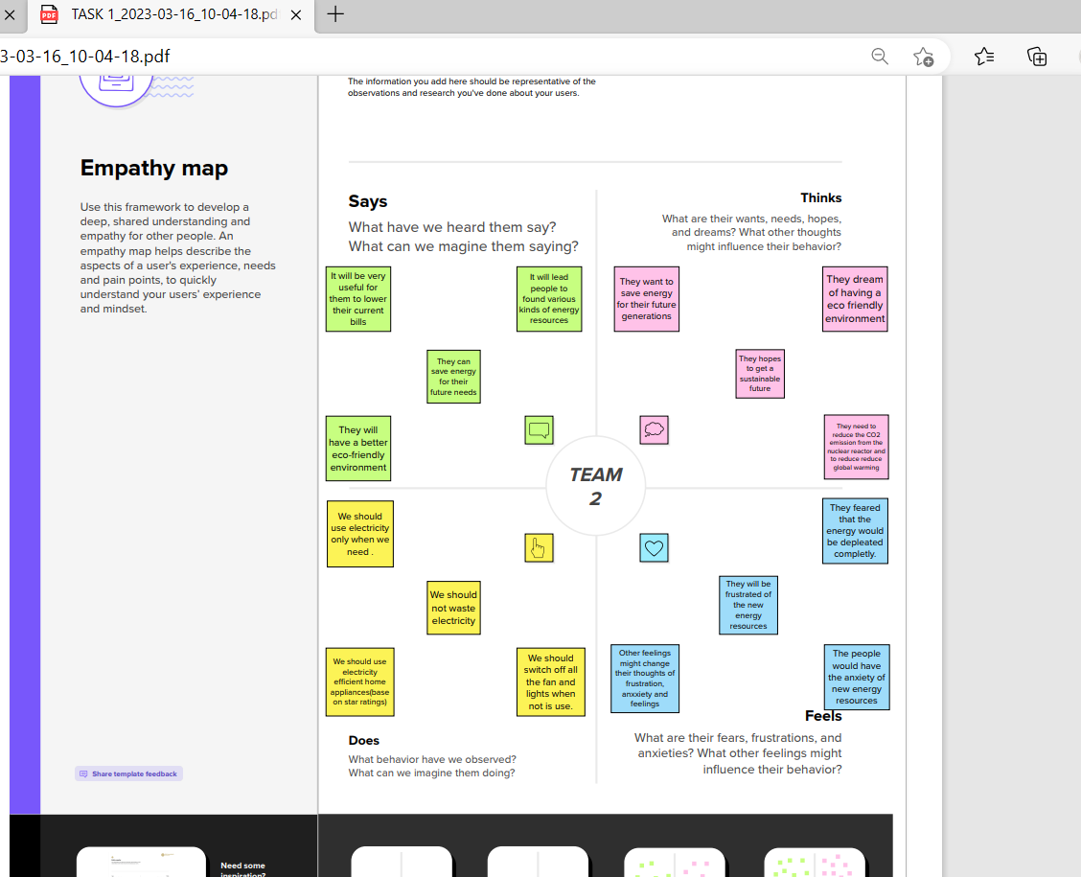

**2.2 Ideation & Brainstorming Map:**

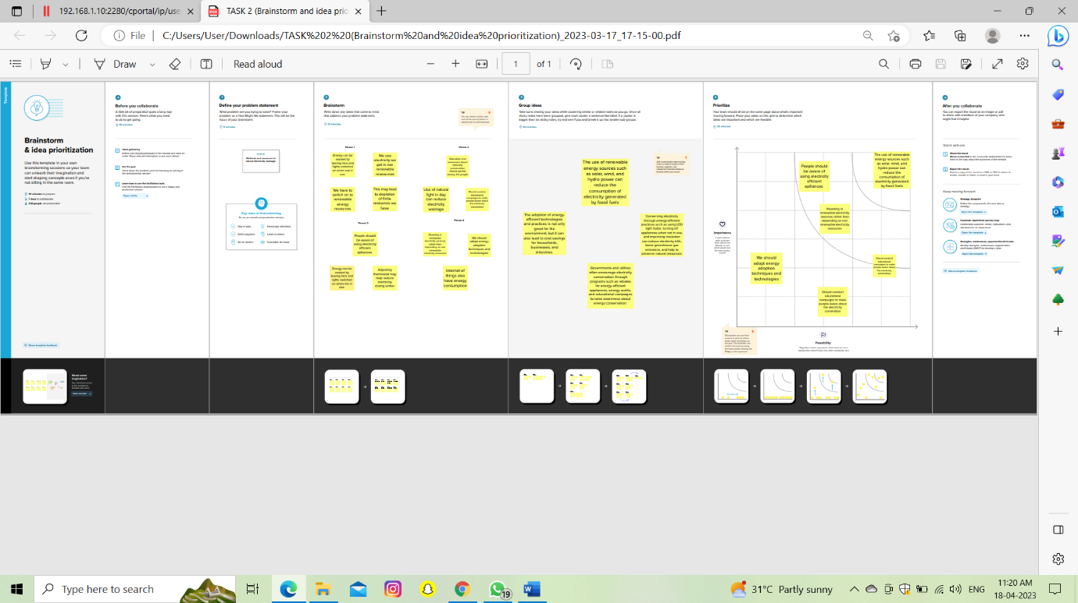

**3. RESULT**

**DASHBOARD 1:**

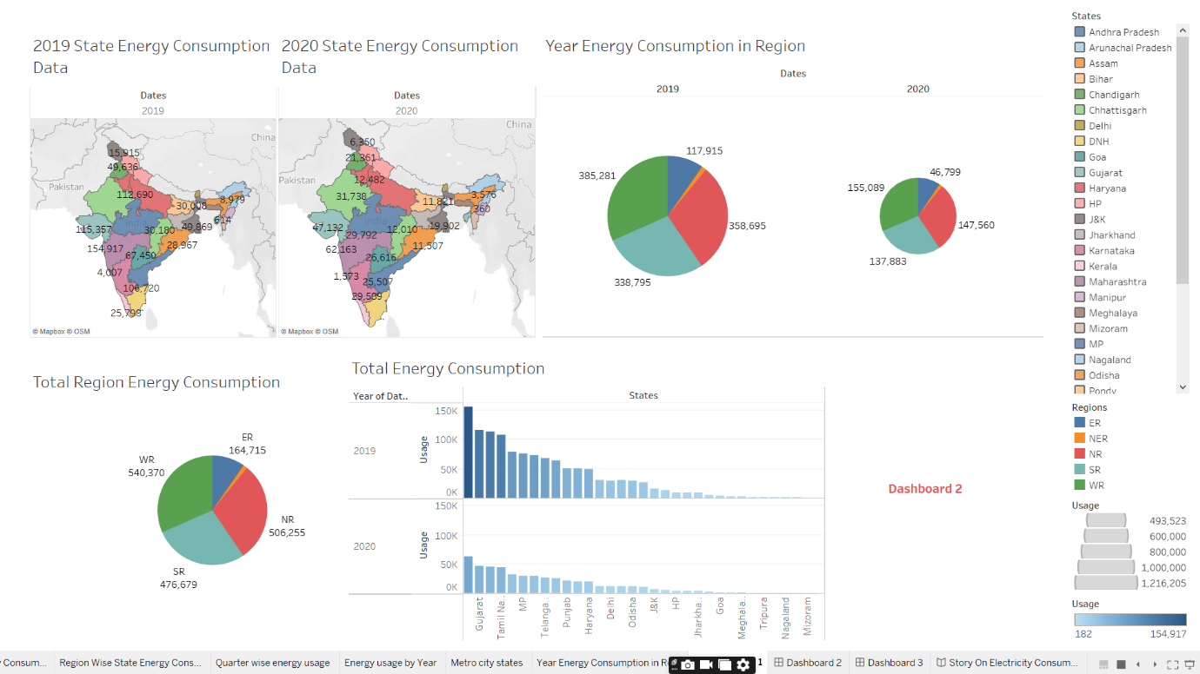

**DASHBOARD 2:**

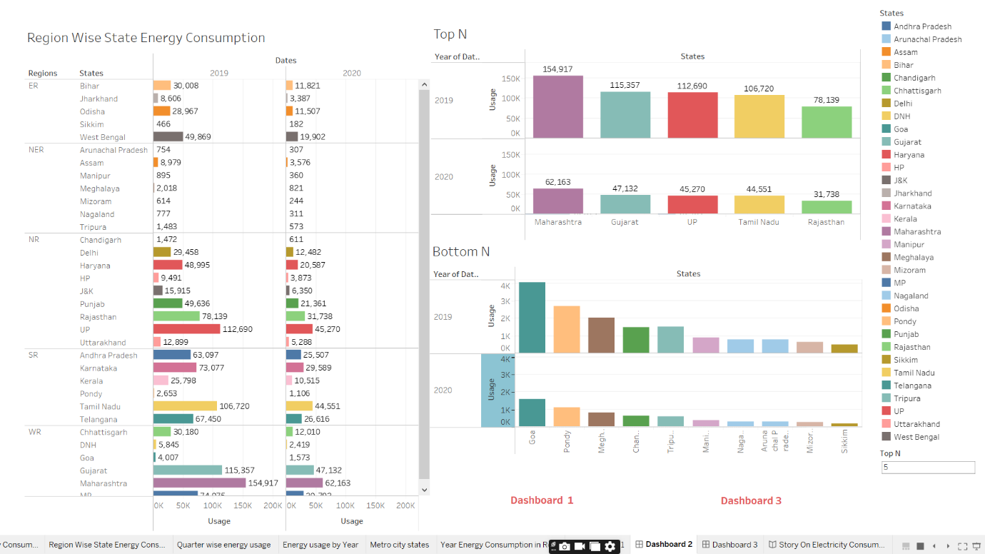

**DASHBOARD 3:**

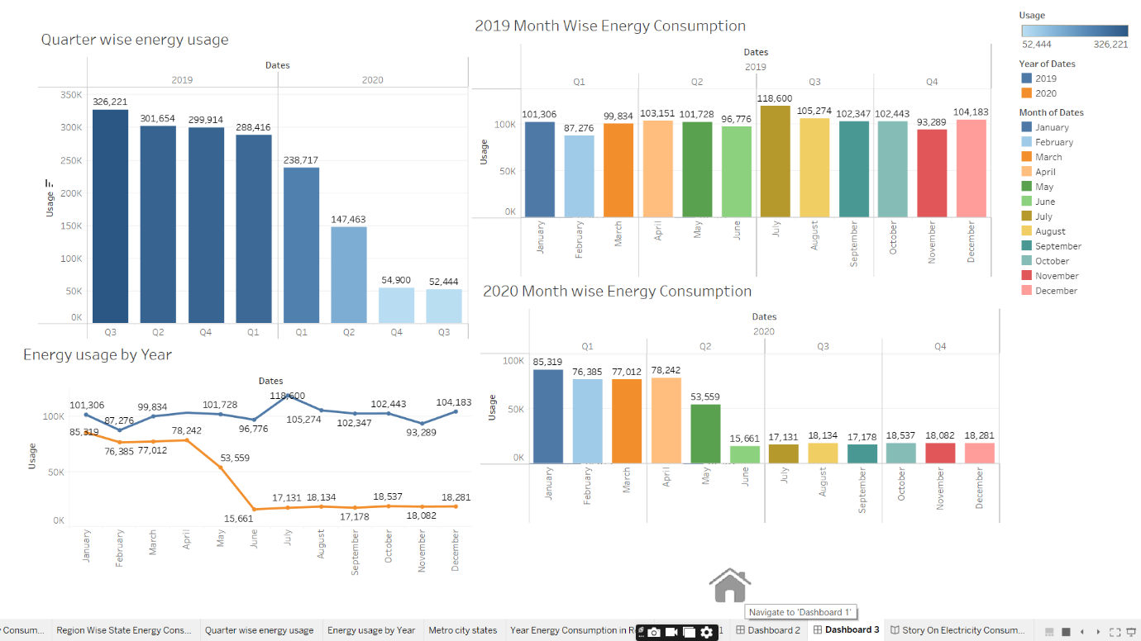

**STORY:**

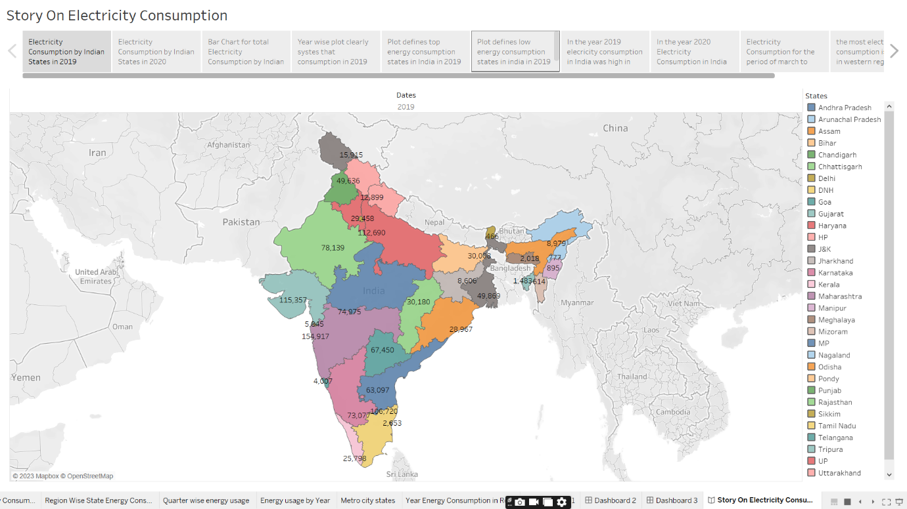

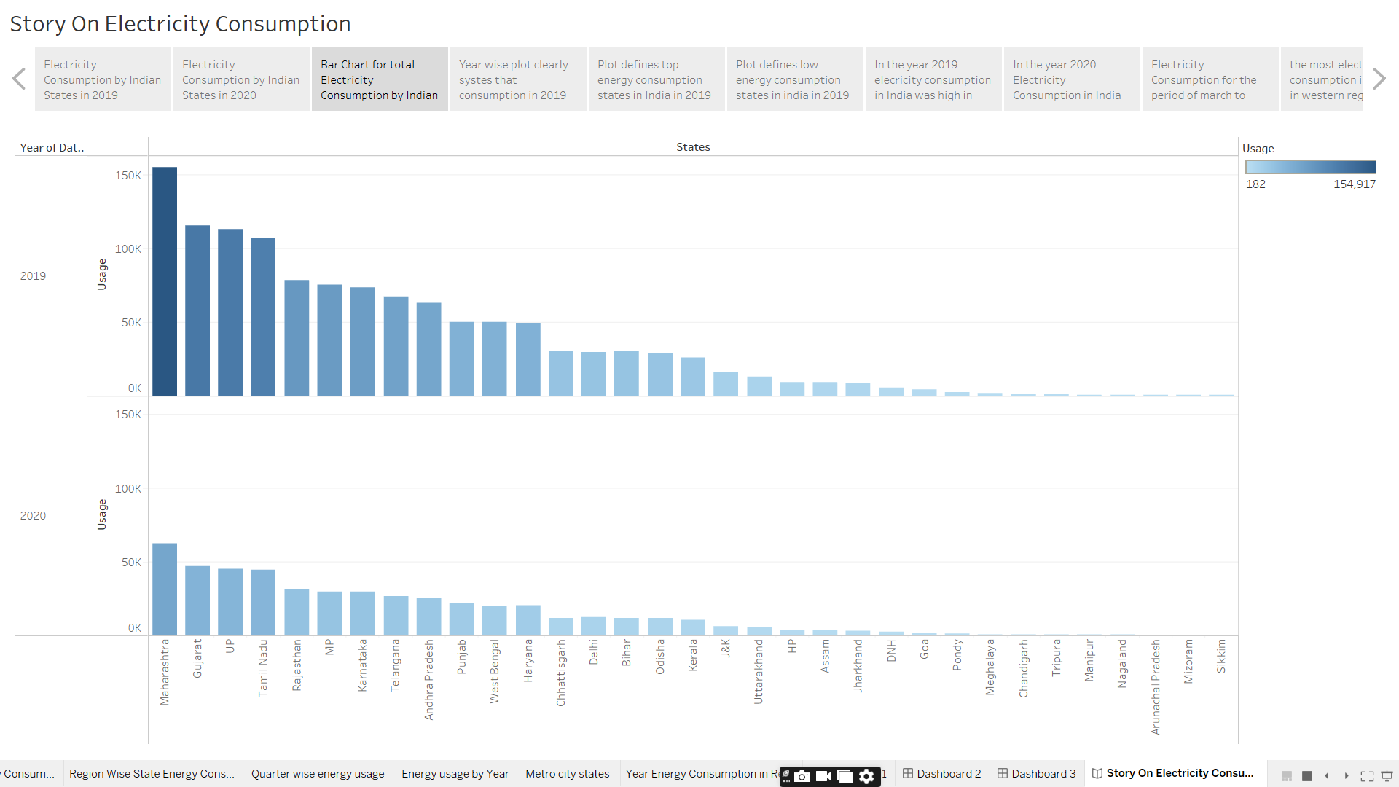

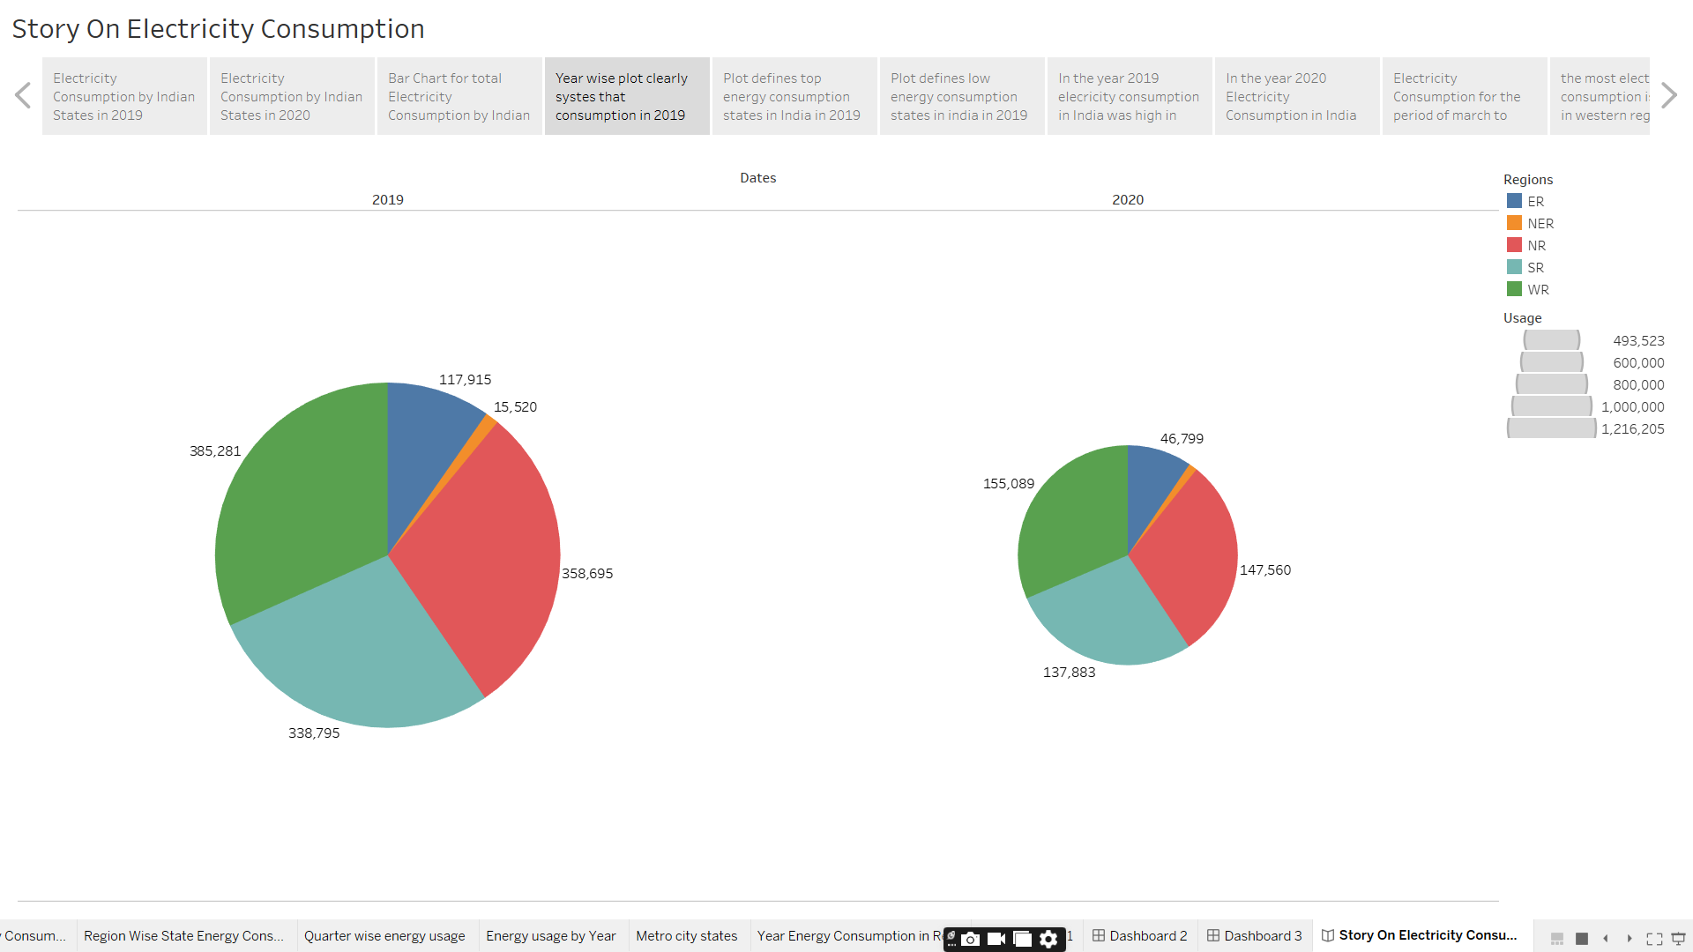

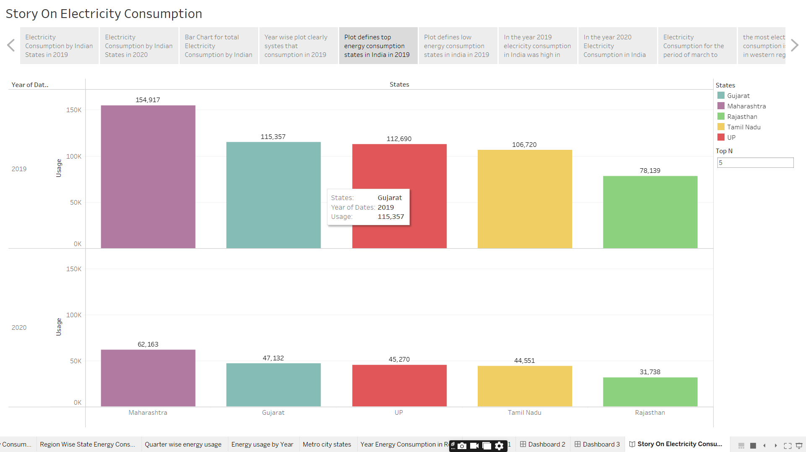

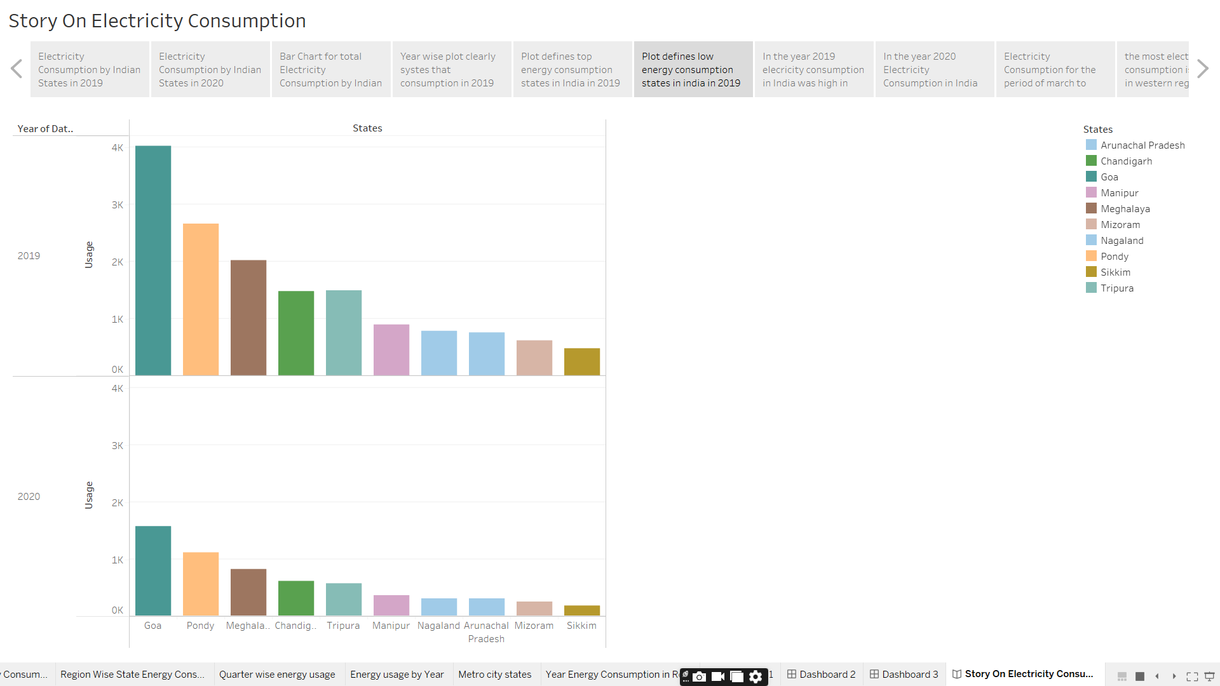

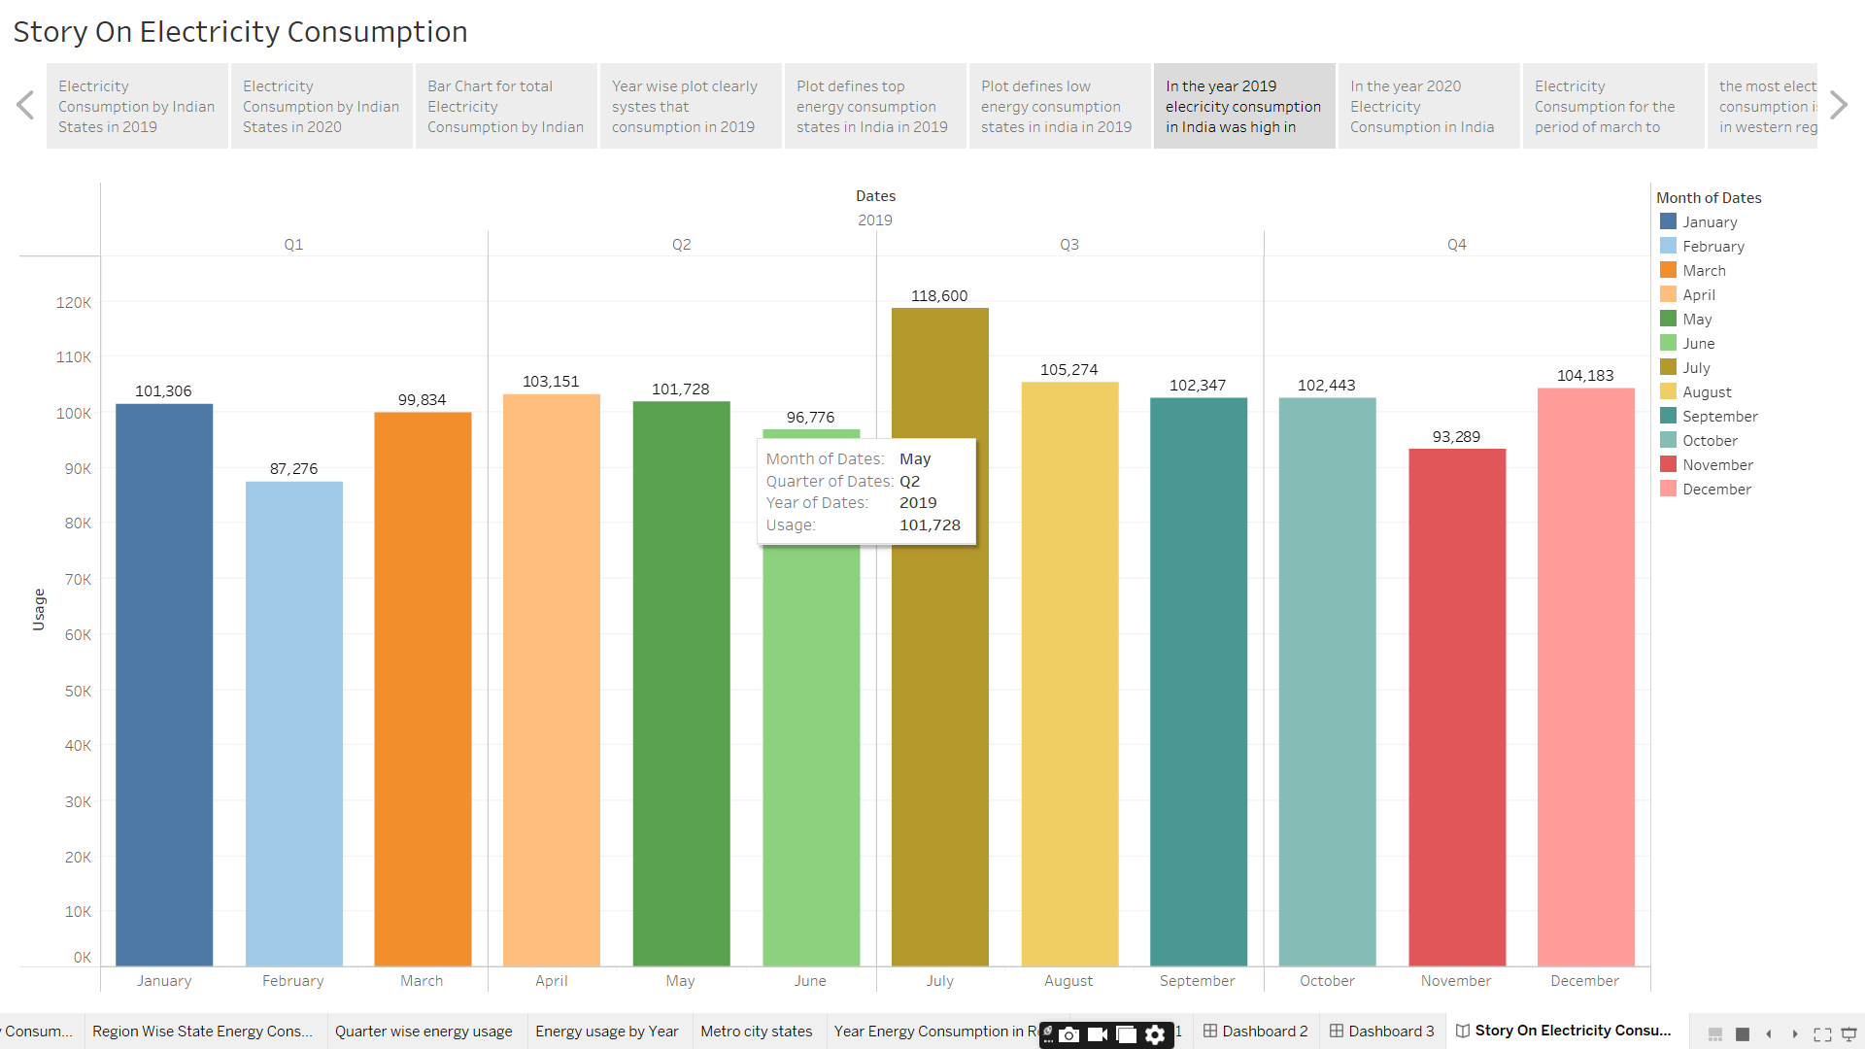

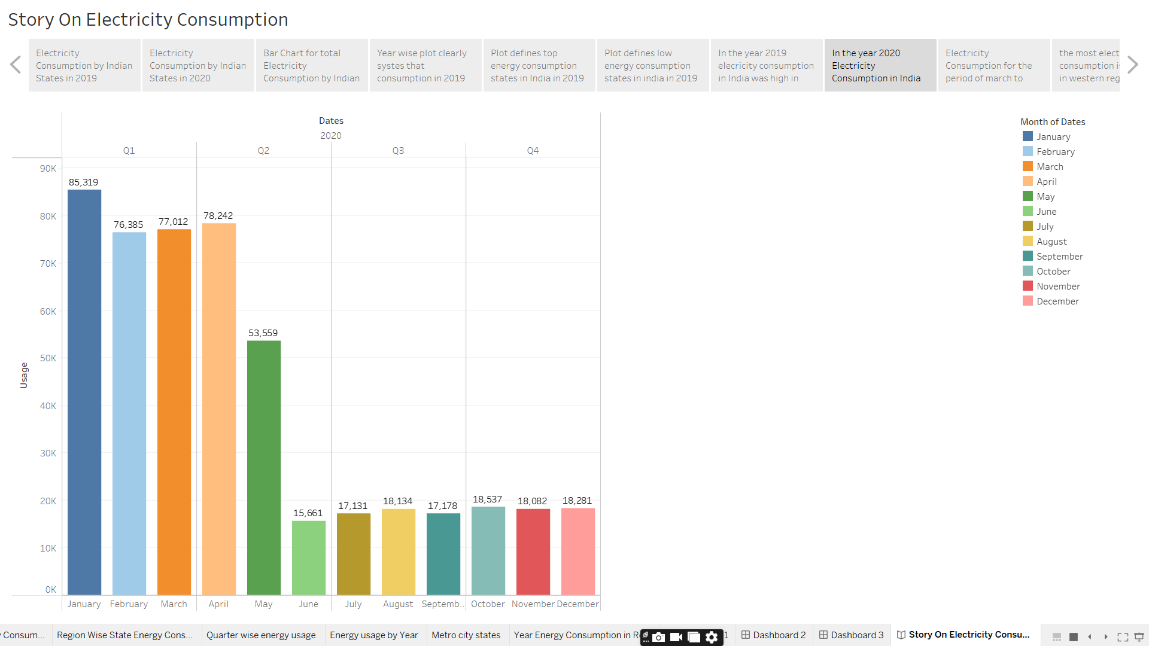

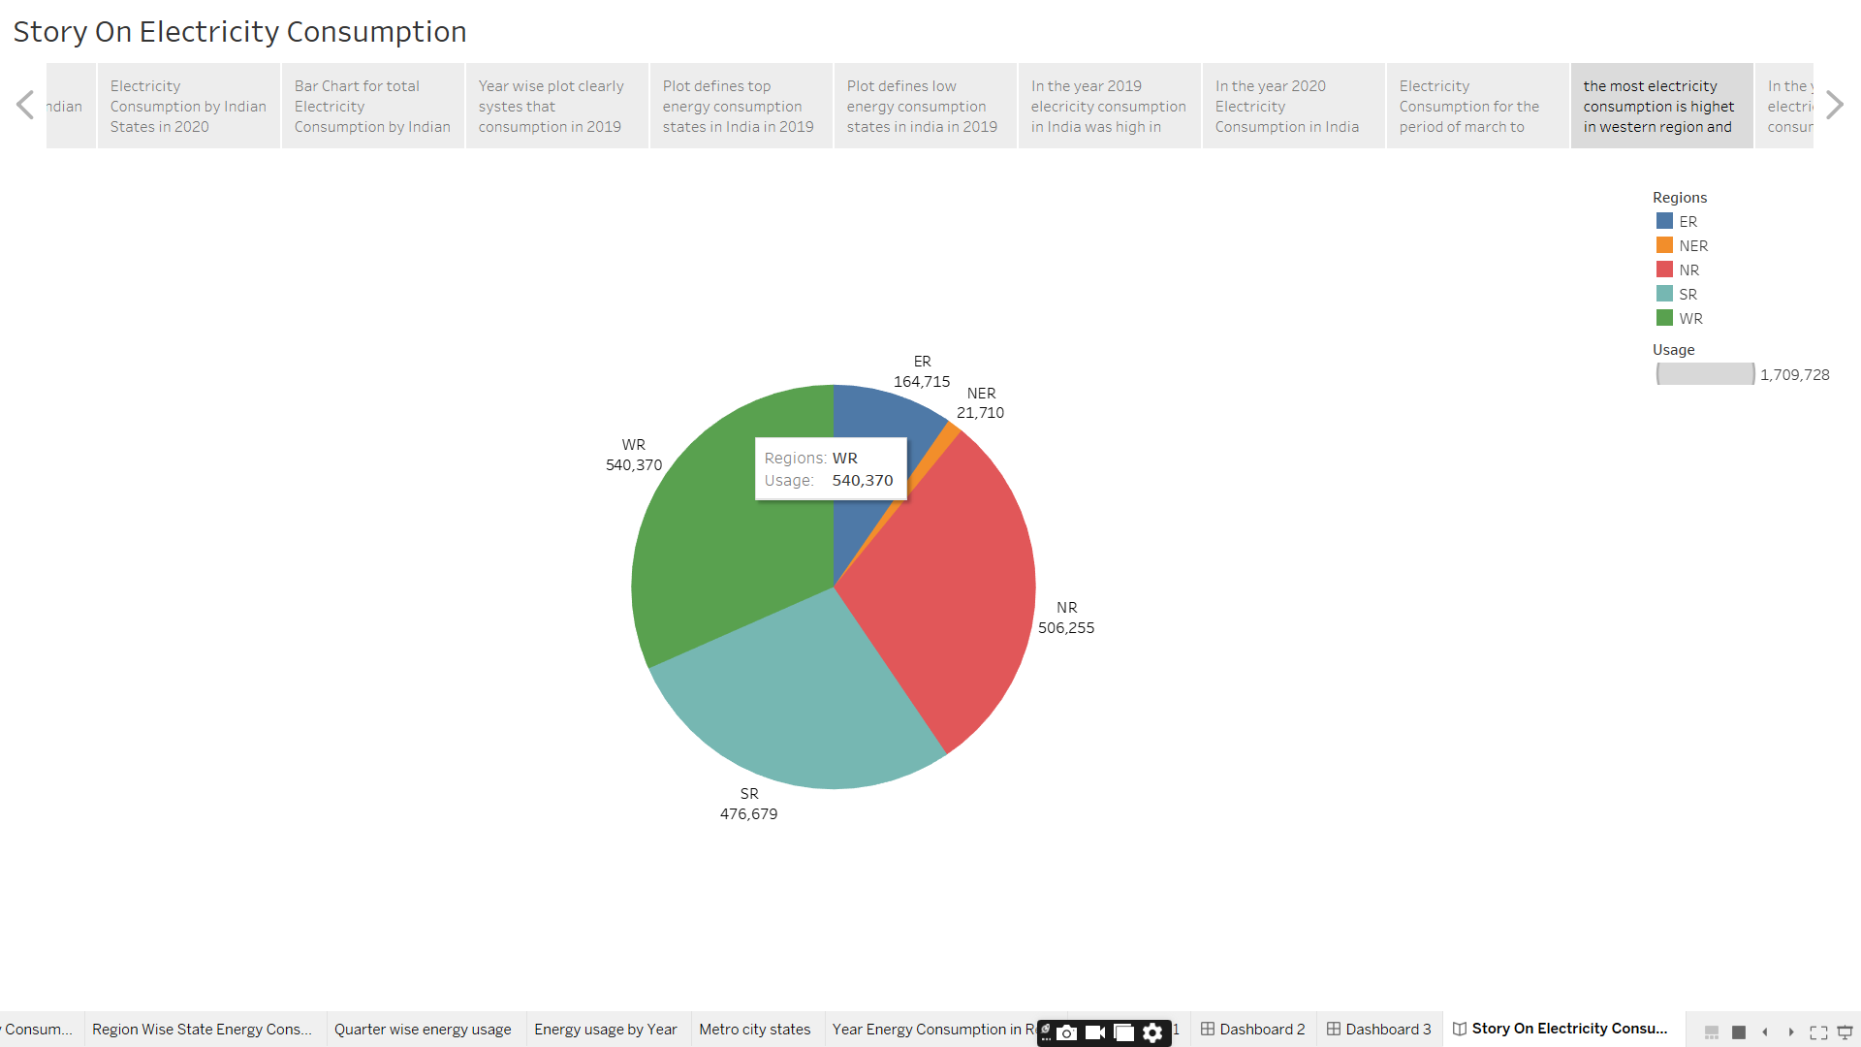

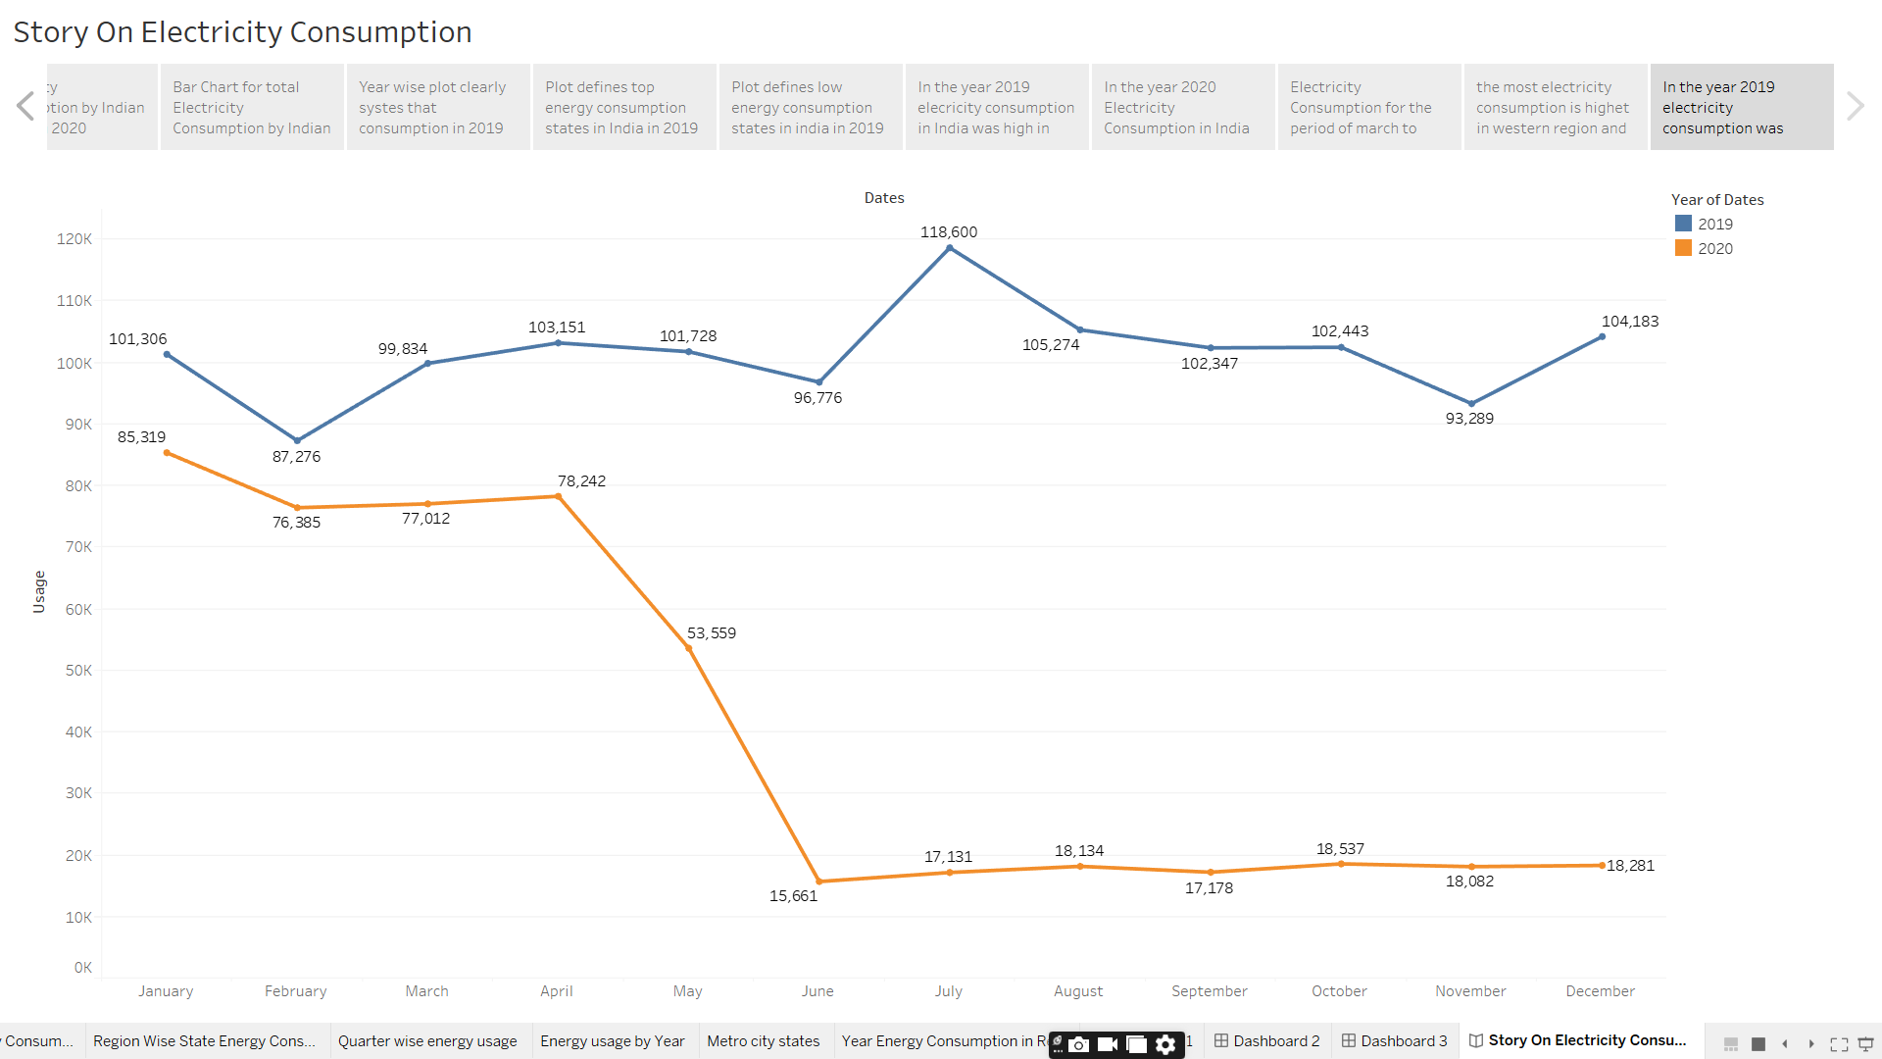

**4. ADVANTAGES & DISADVANTAGES**

**ADVANTAGES:**

1. It is a clean, safe, cheap and convenient source of energy
2. Lower maintenance cost
3. More efficient
4. No tailpipe emission
5. We all know that it  can be set up in many sizes
6. It doesn't require as many employees
7. Reduces greenhouse emission
8. Makes barely any pollution compare to other ways of creating or generating electricity
9. Relatively low maintenance cost
10. Hydroelectric station are inexpensive to operate
11. Hydroelectricity produces no gas emissions or waste
12. A station can operate and run for long periods of time
13. It is renewable

**DISADVANTAGES**

1. More expensive than gasoline
2. Loss of fish species
3. Sometimes messes up wildlife
4. Dependent on precipitation
5. More power plants and more pollution
6. Damming can cause loss of land suitable for agriculture as well as recreation
7. Cost for construction
8. Change in river or stream quality
9. An electric vehicle is not completely emission free
10. In electricity, there are a limited number of feasible sites for a large number of dams
11. Drought can affect power production
12. Hydroelectric natural seasonal changes in river and ecosystems can be destroyed

**5. APPLICATIONS**

By this project,

The visualization of Electricity Consumption helps to collect, process and analyse the date of electricity consumption, It is useful for consumers.

**6. CONCLUSION:**

The supply of energy on Earth is not infinite. Furthermore, it can take a long time to regenerate energy. This makes energy conservation even more important.

**7.FUTURE SCOPE**

By this project, it makes helpful for Electricity consumption in states